Wrapper classes in Java
The wrapper class in Java provides the mechanism to convert primitive into object and object into primitive.
Autoboxing and unboxing feature convert primitives into objects and objects into primitives automatically. The automatic conversion of primitive into an object is known as autoboxing and vice-versa unboxing.

Use of Wrapper classes in Java
Java is an object-oriented programming language, so we need to deal with objects many times like in Collections, Serialization, Synchronization, etc. Let us see the different scenarios, where we need to use the wrapper classes.
- Change the value in Method: Java supports only call by value. So, if we pass a primitive value, it will not change the original value. But, if we convert the primitive value in an object, it will change the original value.
- Serialization: We need to convert the objects into streams to perform the serialization. If we have a primitive value, we can convert it in objects through the wrapper classes.
- Synchronization: Java synchronization works with objects in Multithreading.
- java.util package: The java.util package provides the utility classes to deal with objects.
- Collection Framework: Java collection framework works with objects only. All classes of the collection framework (ArrayList, LinkedList, Vector, HashSet, LinkedHashSet, TreeSet, PriorityQueue, ArrayDeque, etc.) deal with objects only.
The eight classes of the java.lang package are known as wrapper classes in Java. The list of eight wrapper classes are given below:
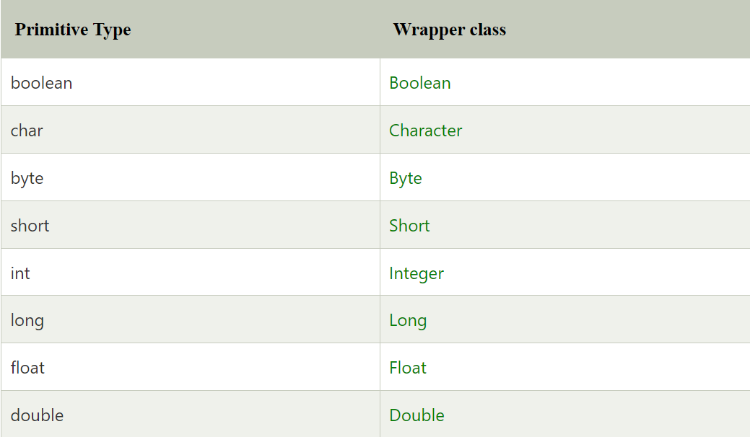

Autoboxing
The automatic conversion of primitive data type into its corresponding wrapper class is known as autoboxing, for example, byte to Byte, char to Character, int to Integer, long to Long, float to Float, boolean to Boolean, double to Double, and short to Short.
Wrapper class Example: Primitive to Wrapper
- //Java program to convert primitive into objects
- //Autoboxing example of int to Integer
- public class WrapperExample1{
- public static void main(String args[]){
- //Converting int into Integer
- int a=20;
- Integer i=Integer.valueOf(a);//converting int into Integer explicitly
- Integer j=a;//autoboxing, now compiler will write Integer.valueOf(a) internally

- System.out.println(a+" "+i+" "+j);
- }}

Unboxing
The automatic conversion of wrapper type into its corresponding primitive type is known as unboxing. It is the reverse process of autoboxing.
Wrapper class Example: Wrapper to Primitive
- //Java program to convert object into primitives
- //Unboxing example of Integer to int
- public class WrapperExample2{
- public static void main(String args[]){
- //Converting Integer to int
- Integer a=new Integer(3);
- int i=a.intValue();//converting Integer to int explicitly
- int j=a;//unboxing, now compiler will write a.intValue() internally

- System.out.println(a+" "+i+" "+j);
- }}

Java Wrapper classes Example
- //Java Program to convert all primitives into its corresponding
- //wrapper objects and vice-versa
- public class WrapperExample3{
- public static void main(String args[]){
- byte b=10;
- short s=20;
- int i=30;
- long l=40;
- float f=50.0F;
- double d=60.0D;
- char c='a';
- boolean b2=true;

- //Autoboxing: Converting primitives into objects
- Byte byteobj=b;
- Short shortobj=s;
- Integer intobj=i;
- Long longobj=l;
- Float floatobj=f;
- Double doubleobj=d;
- Character charobj=c;
- Boolean boolobj=b2;

- //Printing objects
- System.out.println("---Printing object values---");
- System.out.println("Byte object: "+byteobj);
- System.out.println("Short object: "+shortobj);
- System.out.println("Integer object: "+intobj);
- System.out.println("Long object: "+longobj);
- System.out.println("Float object: "+floatobj);
- System.out.println("Double object: "+doubleobj);
- System.out.println("Character object: "+charobj);
- System.out.println("Boolean object: "+boolobj);

- //Unboxing: Converting Objects to Primitives
- byte bytevalue=byteobj;
- short shortvalue=shortobj;
- int intvalue=intobj;
- long longvalue=longobj;
- float floatvalue=floatobj;
- double doublevalue=doubleobj;
- char charvalue=charobj;
- boolean boolvalue=boolobj;

- //Printing primitives
- System.out.println("---Printing primitive values---");
- System.out.println("byte value: "+bytevalue);
- System.out.println("short value: "+shortvalue);
- System.out.println("int value: "+intvalue);
- System.out.println("long value: "+longvalue);
- System.out.println("float value: "+floatvalue);
- System.out.println("double value: "+doublevalue);
- System.out.println("char value: "+charvalue);
- System.out.println("boolean value: "+boolvalue);
- }}

